How to create ADLS storage accounts

1. Search storage accounts in search bar
2. Create storage account using create button

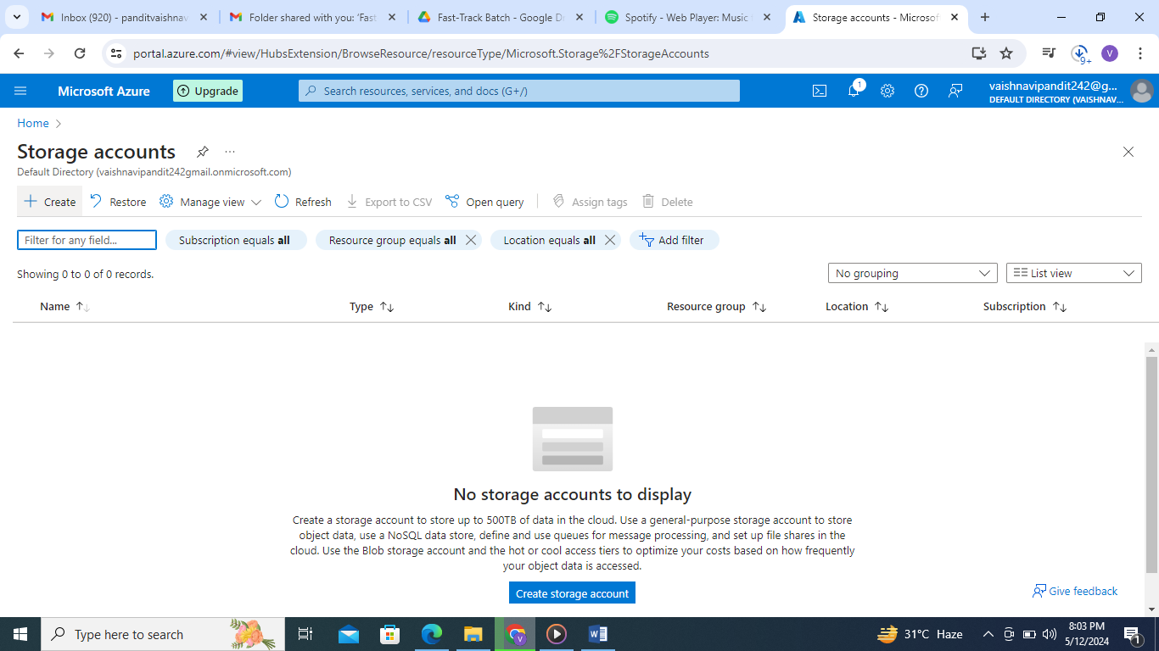

1. Now add name of storage account

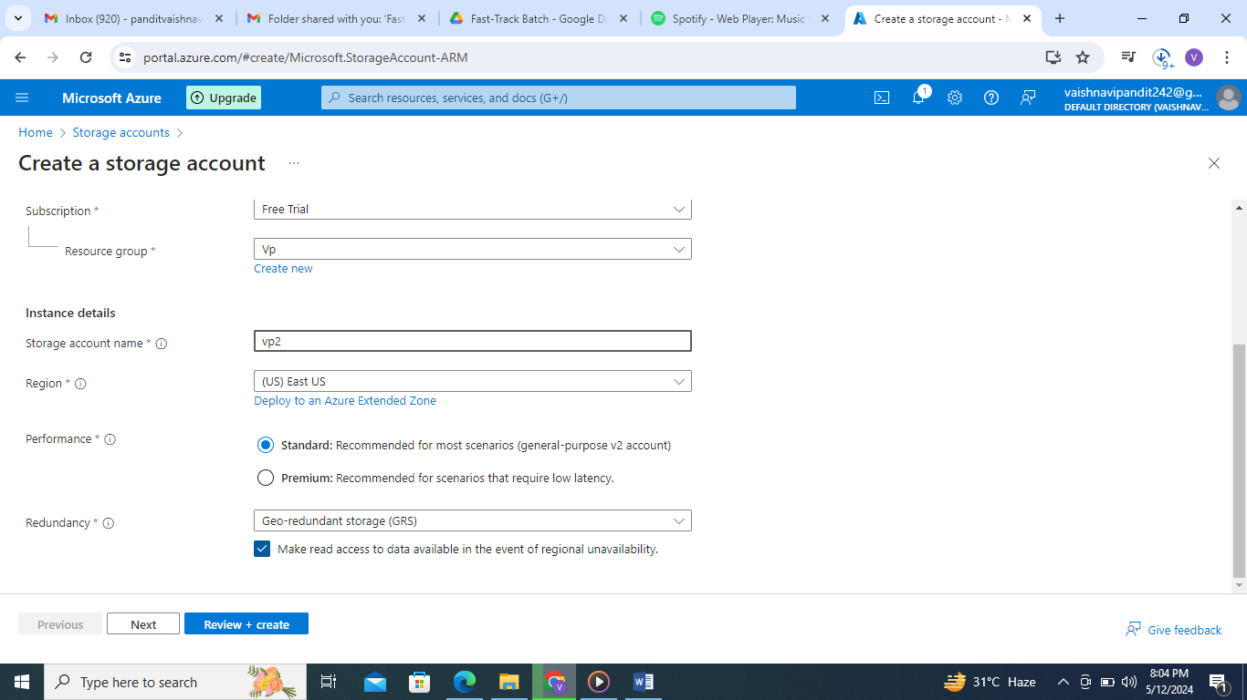

1. Now go to advanced

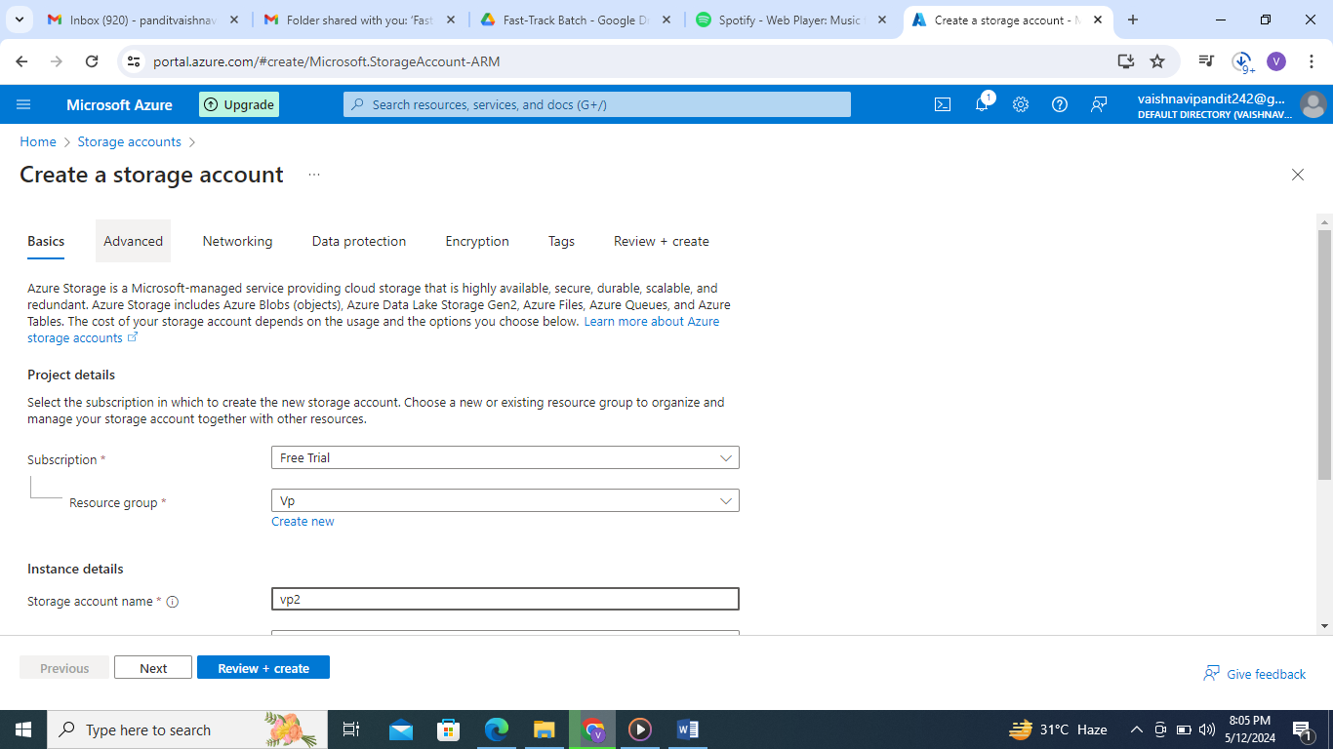

1. Now enable hierarchical namespace in advance and create

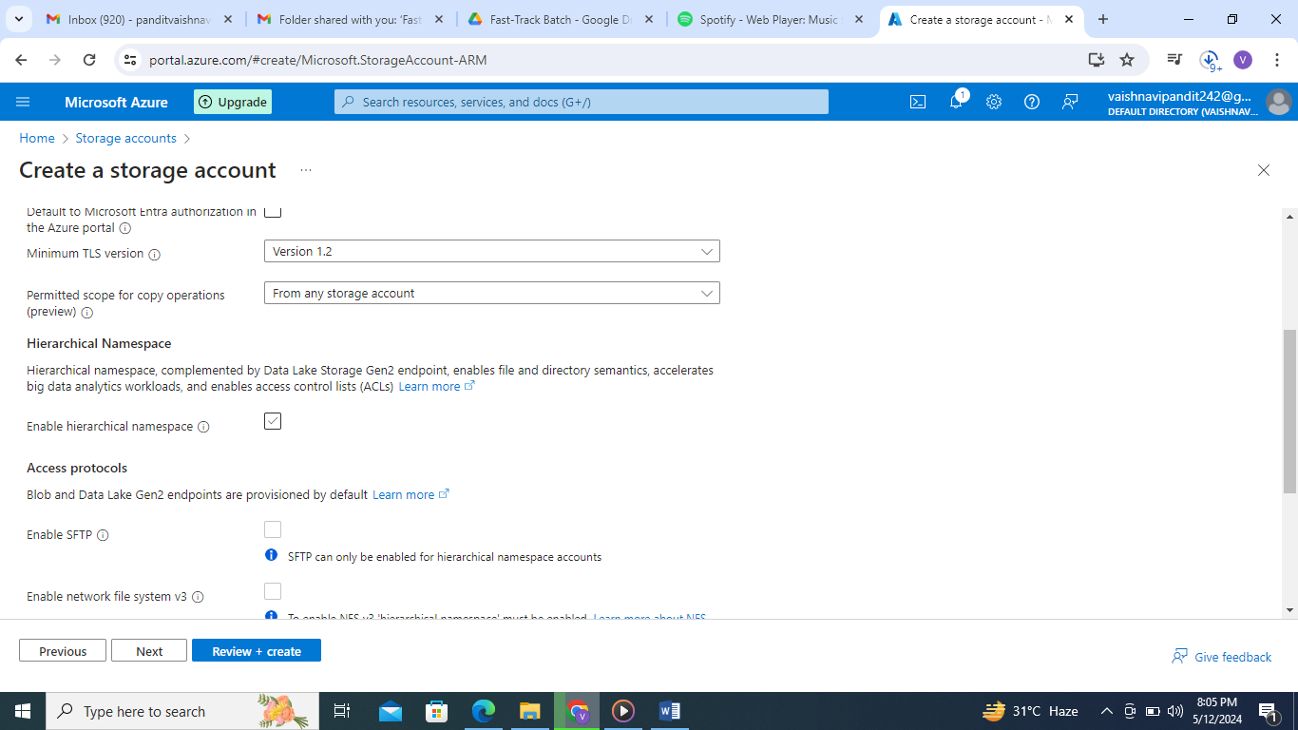

1. Now go to vp2 adls storage account

And create container

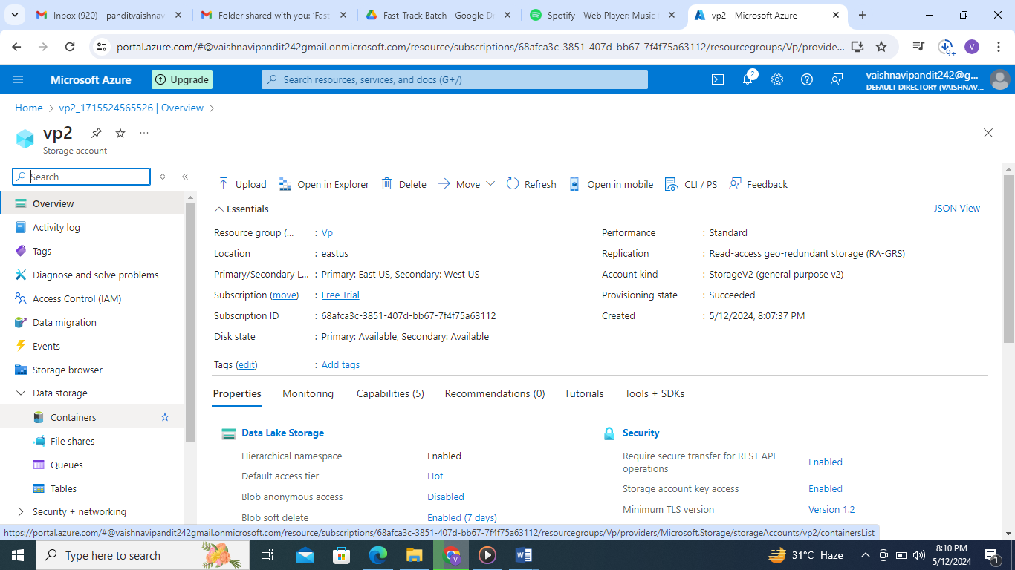

1. Add container name and create

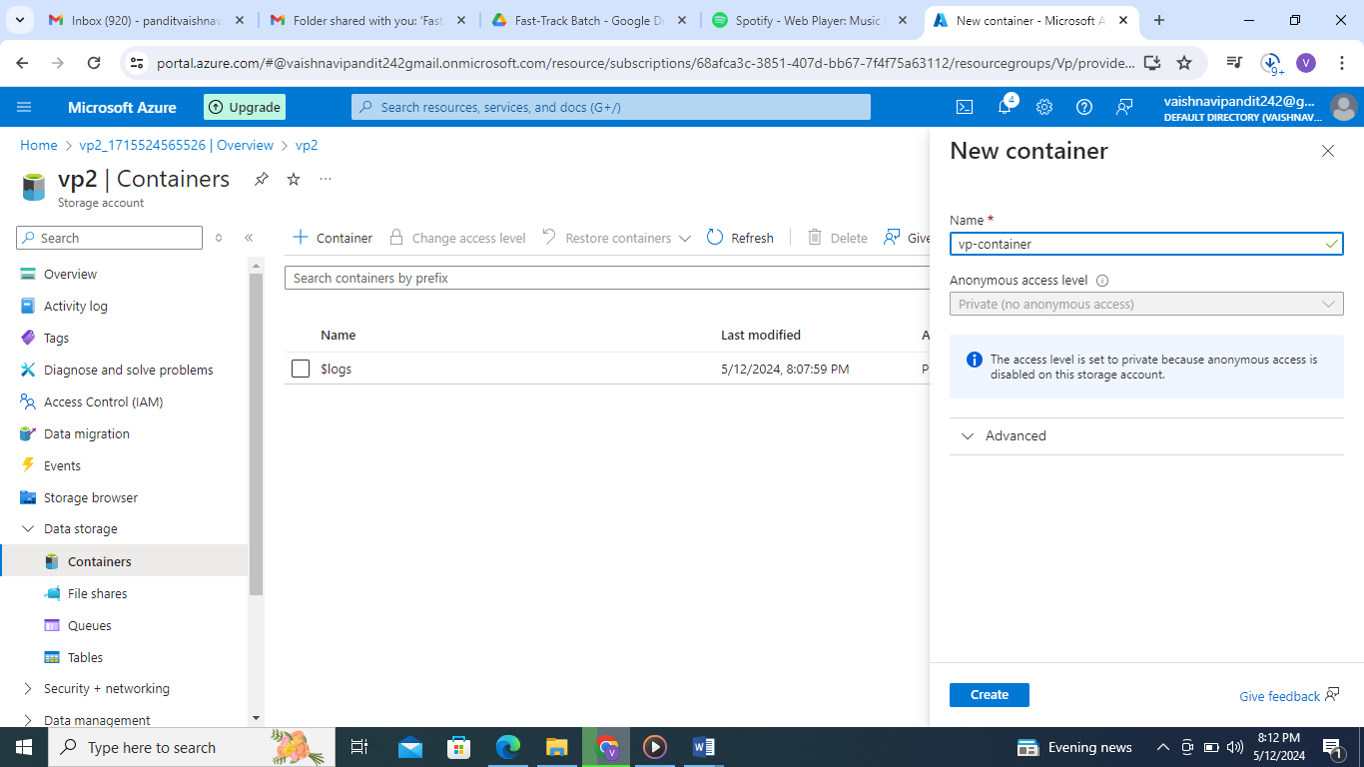

1. Now go to container vp-container

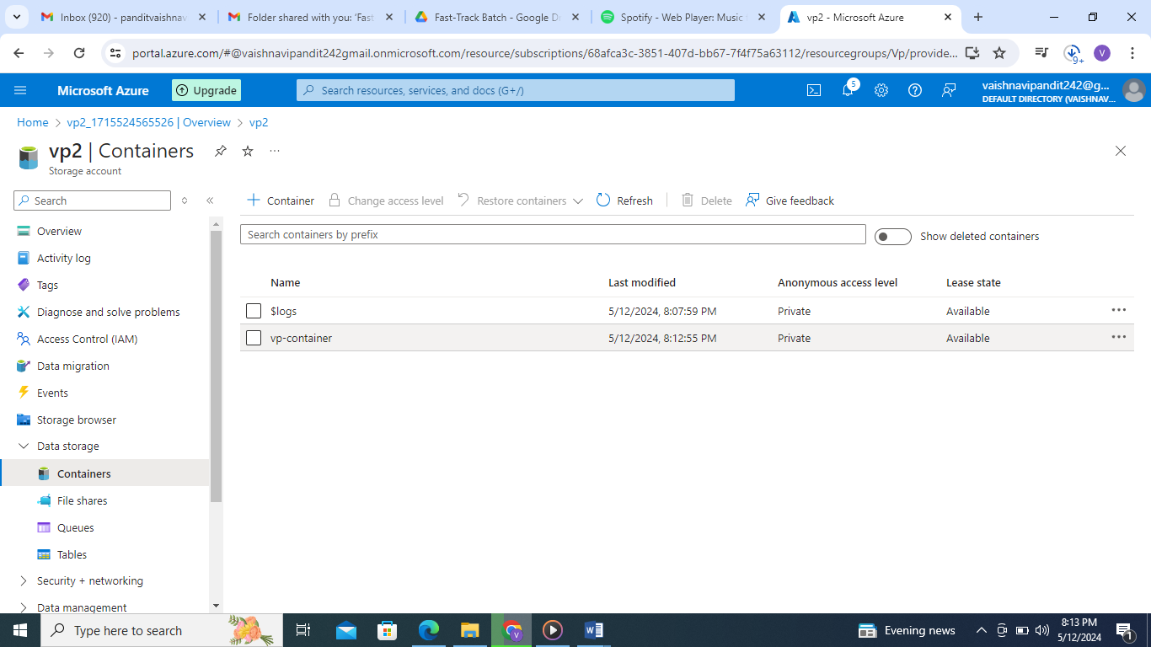

1. Create directory

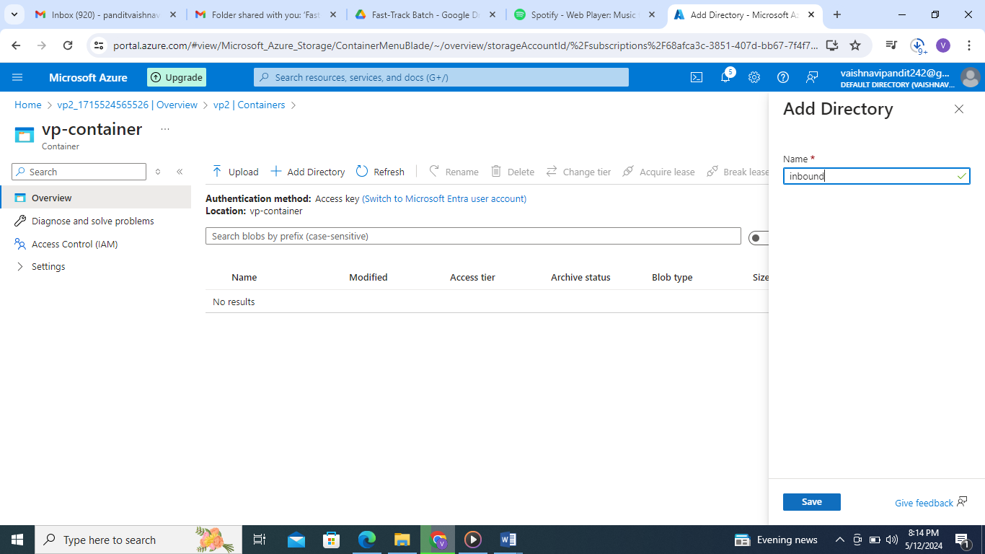

1. Go to directory

Upload file

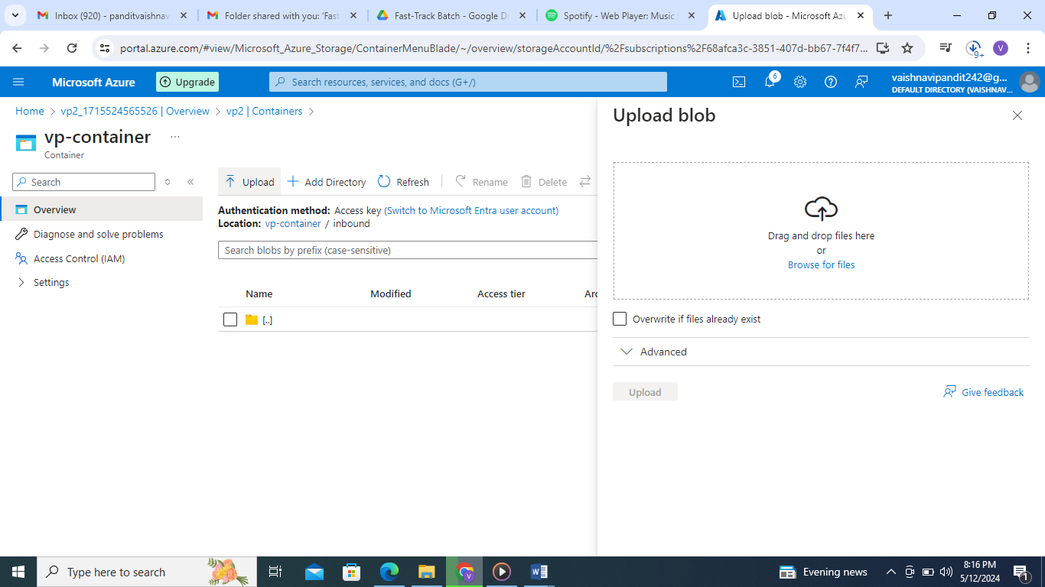

1. Upload file using drop

